Sunset Valley Talent
Shines Bright!

Please complete the Google Form in its entirety by Friday, January 23rd, 2026. Don’t forget to include a Wallet-Size Photo of your child with the signed form.

Important!! If you have any questions, please email us at talentshow@svepta.com

The Talent Show will take place on Friday, February 20th, 2026, at 6:30PM at Norwin Middle School. Performers should report to the Middle School no later than 5:45PM.

Dress Rehearsal:
Thursday, February 19th, 2026, at 6:00PM at Norwin Middle School.
ALL costumes must be worn during the dress rehearsal!
Please note that the appropriateness of musical lyrics, act content, and costumes will be reviewed and enforced by the Talent Show Chairperson(s).

Stage Crew/Greeter Opportunities:
Available for 4th Graders Only.
For more information and to complete the application form, visit Sunset Valley PTA Talent Show Page.

Forms are due by Friday, January 23rd, 2026.

Music Submission:
Submit music in MP3 format only – YouTube links are not acceptable due to poor sound quality. Music will be played as submitted, so please ensure it is properly edited. If your music requires edits, it must be submitted by January 23rd, 2026. The final version must be no longer than two minutes. Each student is allowed only one act, and songs will not be repeated.

All acts will be accepted on first–come, first-served basis. Please make sure your child has fully prepared act before the dress rehearsal – Come prepared!
**The Talent Show is open to all Sunset Valley students in grades K-4**
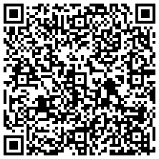Link to Permission Form

